excessweather

Parametric Seismic Policies.

Seismic events, in the form of earthquakes and tsunamis, have produced some of the worlds largest natural disasters. Events in Kobe, San Francisco, New Zealand and others around the Pacific Ocean all resulted from tectonic activity beneath the earth’s surface.. This has also meant that insurance and reinsurance coverage has been heavily utilised to protect against property damage, business interruption and other losses of revenue. With this sector being so heavily reliant on insurance protection, and property rates hardening year on year due to multiple events, finding price and structure at an affordable level has become more difficult. Parametric coverage could well be the answer to this problem.

Parametric policies have become more and more popular in recent years with weather being the sector where they have really found their place. Weather derivatives have been traded for a many years and with the inclusion of an insurable interest, through a clear correlation between weather events and financial experience, parametric coverage has now moved firmly into the insurance space. This has allowed clients to reduce their need to carry additional risk through an increased decutible on their traditional cover. Due to earthquake events being recorded by a recognized, independent organization ( the USGS), these events can be covered by insurers and reisurers underwriting in the parametric sector.

A parametric policy differs from a traditional indemnity cover by the inclusion of a data/event-based deductible. For seismic events, this comes in the form of a ‘Cat in a Circle’ structure whereby quakes must exceed an agreed level on the Richter Scale and ocuur within the circle(s) for the policy to respond. For example, a hospital in San Francisco may buy a Parametric Seismic ‘Cat in a Circle’ cover to protect their $10m deductible on their normal insurance policy. The client is particularly worried about quakes above 5 on the Richter Scale.This threshold will depend on building codes and structures which dffer all over the world. The following structure may be created (figures are fictitious and are for illustrative purposes only):

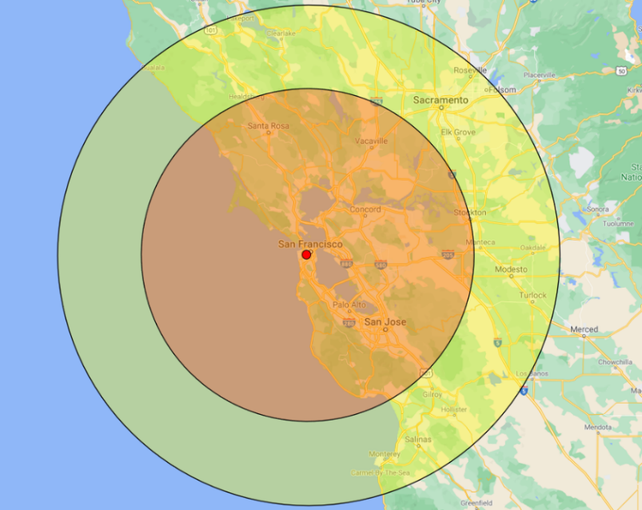

Richter  Measurement | <100km | 100 - 150km
5.0 - 5.9 | 25% | 0%
6.0 – 6.9 | 50% | 25%
7.0 + | 100% | 50%

Earthquake coverage has been bought in the traditional market for hundreds of years but parametric covers have two distinct benefits for the client:

1. Ground Up Coverage.

Parametric policies contain no financial deductible. If the weather/quake threshold is met, and the client sustains a financial loss, the policy will pay. Payout is often scaled by magnitude of event.

2. Immediate Loss Settlement.

The lack of need for loss adjusting, and the payout being largely predicated on publicly available data, mean that payouts can be made within 21 days of the loss event or expiry of the policy.

These policies have a multitude of uses. We have already seen these products used as a replacement to traditional coverages, as a way of reducing or removing a traditional cover’s deductible, or a method to obtain rapid disaster relief with a fast loss settlement.

These policies are very adaptable and the markets we source make each policy unique to the client. In order to achieve this, we start the process by asking some relatively simple questions about the risk and this allows us to investigate the historic weather or seismic activity for the region. The specific questions/pieces of information are:

- Location of Risk(s) – This is the registered address(es) of the locations and the latitude and longitude coordinates

- Loss History – A comprehensive history of losses relating to the desired peril. This allows cross-correlation to occur with historical events.

- Allocated Budget – A rough idea of a budget allow our markets to create a structure which fit the clients finances. Our markets will work backwards from the budget to make sure any structures are affordable.

- Advice on Structure – If you or your client have some idea as to how they would want the structure to react from a shake intensity or financial payout perspective then this is valuable information for our markets to factor in.

- Policy Period – These coverages can be formed on an annual basis or just for a desired period (a period of construction for example).

Contacting Us

John Warwick
john.warwick@excessweather.com

Jamie Warwick
jamie.warwick@excessweather.com

excessweather.com

